Selection Sort

N = 5

arr = {8, 6, 2, 5, 1}

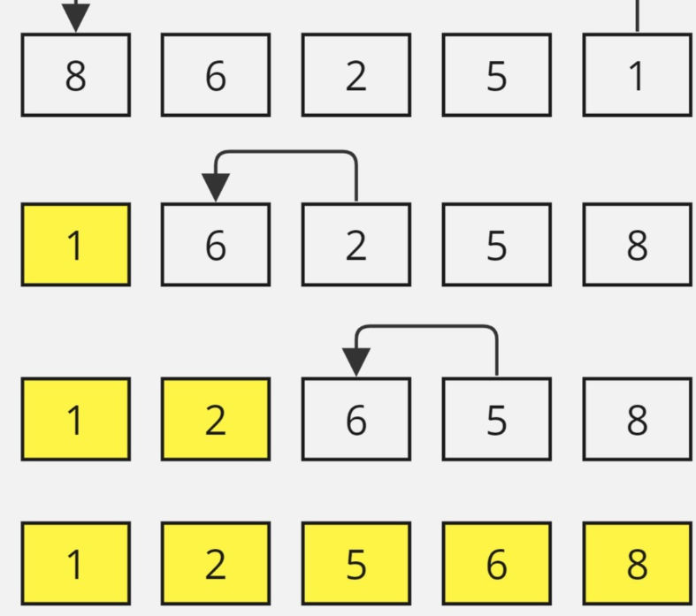

def selectionSort(arr: List[int]) -> None:

    for i in range(len(arr)):

        num=arr[i]

        m=i

        for j in range(i+1,len(arr)):

            if arr[j]<num:

                num=arr[j]

                m=j

        arr[i],arr[m]=arr[m],arr[i]

    return arr

Algo:

1. Start with the entire array as the unsorted part.
2. Find the minimum element in the unsorted part.
3. Swap the found minimum element with the first element of the unsorted part.
4. Move the boundary between the sorted and unsorted parts one element to the right. The element at the boundary is now considered part of the sorted subarray.
5. Repeat steps 2 to 4 until the entire array is sorted.